Dimensional Overlap and S-S and S-R Compatibility:
A Structural Model

Jun Zhang

Department of Psychology, University of Michigan, Ann Arbor, MI 48109, USA
<junz@umich.edu>

The Dimension Overlap (DO) model accounts for stimulus-stimulus (S-S) and stimulus-response (S-R) compatibility effects by perceptual, conceptual or structural similarity/conflict between the relevant stimulus dimension, the irrelevant stimulus dimension, and the response dimension of the task (Kornblum et al., 1990; Kornblum, 1992; Kornblum et al., in press). Here, a geometric representation is given to illuminate the pattern of performance for different stimulus-response configurations of all eight types of stimulus-response ensembles arising under this compatibility “taxonomy”. This structural analysis provides qualitative prediction of relative ordering of RTs.

INTRODUCTION

In simple stimulus-response tasks where subjects respond to given stimuli based on pre-specified rule, subjects often manifest facilitation or interference in performance if there is perceptual/conceptual/structural “similarity” or “conflict” within/among the stimulus and/or response dimensions. A well-known example is the Stroop effect, when subjects are instructed to name the color of certain word (“green”, “red”, etc) that is printed in congruent or incongruent color ink. Such compatibility effects occur when (i) the required response share the same modality (“response dimension”) as that of the stimulus; and/or (ii) the unitary stimulus, while treated as a single gestalt, contains various attributes (“stimulus dimensions”) and is processed as such, though all are not pertinent to the task. A relevant stimulus dimension S_{r} is one that a subject is instructed to attend and map to response R, whereas an irrelevant stimulus dimension S_{i} is one that a subject is supposed to ignore. Despite of task instruction, however, there is a tendency, originating in both nature and nurture, for automatic association among those stimulus-response dimensions that share intrinsic similarity with one another, the so-called dimension overlap or DO (Kornblum et al. 1990; Kornblum, 1992; Kornblum et al., in press). Depending on the presence/absence of DO between any two among S_{r}, S_{i}, and R, the three aspects of a task, a taxonomy for all eight possible types of SR ensembles was proposed (ibid) to unify various compatibility-related paradigms studied in the literature:

Table 1: Kornblum’s taxonomy

Ensemble | S_{r}-R | S_{i}-R | S_{r}-S_{i} | Example in Literature
type 1 | no | no | no | baseline
type 2 | yes | no | no | Fitts-Deininger
type 3 | no | yes | no | Simon-Small
type 4 | no | no | yes | Ericksen/Ericksen
type 5 | yes | yes | no | Hedge-Marsh
type 6 | yes | no | yes | Fitts-like?
type 7 | no | yes | yes | Kornblum et al.
type 8 | yes | yes | yes | Stroop

Inasmuch as the presence/absence of “overlap(s)” among the relevant stimulus (S_{r}), the irrelevant stimulus (S_{i}), and the response (R) dimensions distinguishes various experimental paradigms, the nature of such overlap when it exists, i.e., whether the overlap represents a similarity (“congruent”, “consistent”) or a conflict (“incongruent”, “inconsistent”) between the respective dimensions, determines systematic difference in performance (e.g., reaction-time) across trials. The purpose of this paper is to (i) provide a geometric depiction of this “dimension overlap” model of stimulus-response compatibility, and (ii) show that the pattern of behavioral performance (e.g., RT) under different stimulus-response configurations, i.e., unique combination of (in)congruency or (in)consistency between S_{r}, S_{i}, and R, can indeed be accounted for, at least qualitatively, by mere structural analysis of the underlying problem.

GEOMETRIC REPRESENTATION OF SR COMPATIBILITY

For simplicity, we consider two-choice tasks where task instructions map/assign individual (binary-valued) stimuli to individual responses. A trial is uniquely specified by the value of (i) the relevant stimulus dimension, (ii) the irrelevant stimulus dimension if any, and (iii) the response dimension. Any allowable combination of stimulus and response values (under mapping instruction) is called a stimulus-response configuration, which is an element of a given type of stimulus-response ensemble (an ensemble is a collection of all such configurations). Geometrically, it can be represented by a cube in which the three axes record the (binary) values of the three dimensions:
r₁: relevant stimulus dimension;
r₂: irrelevant stimulus dimension;
r₃: response dimension.
Any vertex of the cube thus represents an allowable combination of SR values (configuration) in a specific trial of an experiment. Take type 8 ensemble (Stroop task) for example, the coordinates of a vertex specify the values of each of the three stimulus-response dimensions in the form: “the subject utters the word ‘red’ upon presentation of the word green printed in red ink”. The eight vertices (unique configurations) arising from all possible factorial combinations are labeled A, B, C, D, A’, B’, C’, D’.

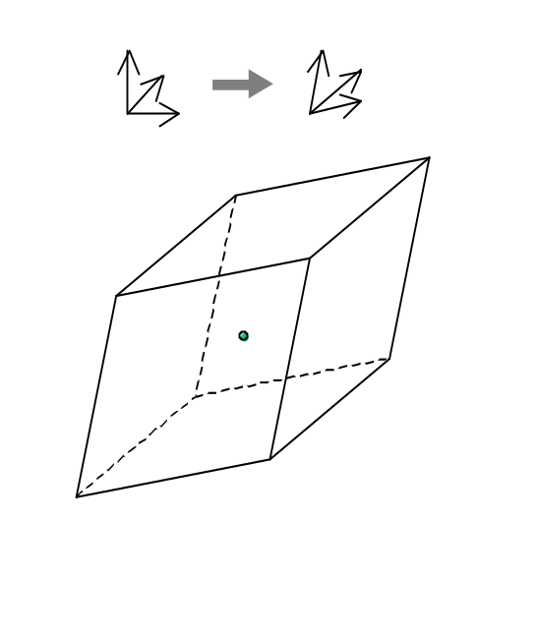

Figure 1 SR Configuration Cube

Let r₁, r₂, r₃ denote the three base vectors of the cube, with fixed lengths (in general |r₁|, |r₂|, |r₃| are unequal). The distance from a vertex to the origin O will be construed as the "driving force" for a behavioral response and, by construction, is inversely related to the reaction time for a particular SR configuration. When the base vectors are orthogonal to one another, the distances from all vertices to origin are equal. This is interpreted as the neutral, baseline condition (type 1 ensemble) where performance (reaction times) is equal for all eight SR configurations.

Imagine that the base vectors r₁, r₂, r₃ can now rotate with respect to one another so that the cube becomes a diamond-shaped paralleloid. The distances from the vertices to the origin become unequal, with some vertices being stretched farther away and others drawn nearer to the origin. The idea is to arrive at a representation of different stimulus-response compatibility conditions by combinations of differential rotations of each of the three bases. The angle between any two of the three base vectors would be a quantitative representation of the degree of dimensional overlap (DO) between the respective dimensions - the greater the degree of DO, the more it deviates from 90º which represents the baseline (neutral) condition. The resultant change of distances from each vertex (a dependent variable) would then reflect the effect of DOs on performance (e.g., RT) on single trials. Without loss of generality, let the three axes all tilt towards the first quadrant and we assign vertices accordingly:

A and A’: S_{r}-S_{i} consistent, S_{r}-R congruent,
S_{i}-R consistent;
B and B’: S_{r}-S_{i} inconsistent, S_{r}-R congruent,
S_{i}-R inconsistent;
C and C’: S_{r}-S_{i} inconsistent, S_{r}-R incongruent, S_{i}-R consistent;
D and D’: S_{r}-S_{i} consistent, S_{r}-R incongruent,
S_{i}-R inconsistent.

Again, in the example of Stroop task where color ink is the relevant stimulus dimension r₁, “color word” is the irrelevant stimulus dimension r₂, color name is the response dimension r₃ (red values are positive and green values are negative along any axis), the SR configurations are:

A: say red to word “red” in red ink
A’: say green to word “green” in green ink
B: say red to word “green” in red ink
B’: say green to word “red” in green ink
C: say green to word “green” in red ink C’: say red to word “red” in green ink
D: say green to word “red” in red ink
D’: say red to word “green” in green ink

Note that vertex-pairs A-A’, B-B’, C-C’, D-D’ correspond to identical compatibility condition. The pairs A-A’ and B-B’ describe congruent mapping instruction condition, whereas the pairs C-C’, D-D’ describe incongruent mapping condition.

We write down the vectors representing vertices A, B, C, D in terms of r₁, r₂, r₃:
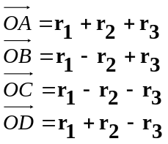 (1)
and then calculate their (and by symmetry, their partner’s) distances to the origin O by performing dot product:
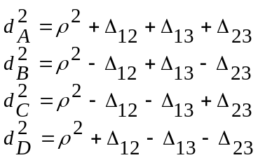 (2)

where
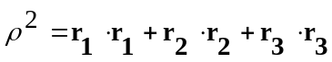 (3)
is a baseline constant and
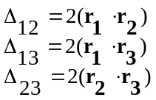 (4)
define dimensional “overlaps”:
Δ₁₂: overlap between S_{r}-S_{i};
Δ₁₃: overlap between S_{r}-R;
Δ₂₃: overlap between S_{i}-R.
The baseline term (3) represents the driving force for reaction time under the neutral condition (type 1 ensemble). Since r₁, r₂, r₃ may not be of equal length, the magnitude of ρ² depends on the nature of the particular behavioral task: the time for encoding and analyzing the stimulus and for preparing and executing the response. However, it is independent of particular SR configurations. The dot-product terms (4), on the other hand, characterize the degree of dimensional overlap between the respective stimulus/response dimensions. Each term can be zero if the two base vectors are orthogonal (cos 90º = 0), representing no dimensional overlap between the corresponding S-S or S-R dimensions. Otherwise, since r₁, r₂, r₃ all tilt towards the first quadrant by construction, the dot-product terms (Δ₁₂, Δ₁₃, and Δ₂₃) are always positive, with their values representing the magnitude of respective dimensional overlap. The consistent (congruent) or inconsistent (incongruent) conditions are reflected by the positive or negative signs in their contributions towards d² in (2). This is summarized in the following table:

Table 2: Contribution of DOs to individual SR configuration

Configuration | S_{r}-R | S_{i}-R | S_{r}-S_{i}
A-A’ | + | + | +
B-B’ | + | - | -
C-C’ | - | + | -
D-D’ | - | - | +

ORDERING OF REACTION TIMES

The driving force for response under various stimulus-response ensemble types is given by (2) with (4). Of course, apart from type 1 (neutral condition), each ensemble type has some non-vanishing term(s) of Δ₁₂, Δ₁₃, and Δ₂₃. Thus, the above model provides qualitative predictions of RT ordering for different SR configurations in individual ensembles.

Type 2, type 3, and type 4 ensembles: the model predicts that consistent/congruent configurations always have shorter RT compared to inconsistent/incongruent ones. This has been amply documented in the literature, where type 2 ensemble is known as stimulus-response compatibility (Fitts & Deininger, 1954), type 3 ensemble as Simon effect (Simon & Small, 1969), and type 4 ensemble as Ericksen flanker task (Ericksen & Ericksen, 1974).

Type 5 ensemble: This is the Hedge & Marsh (1975) task where “reversal” of Simon (type 3) effect was observed for the incongruent mapping condition. The pattern of RT distribution was accounted for by a “dual process” theory (De Jong et al., 1994; Zhang & Kornblum, 1997). The automatic process and the controlled process therein are elaborations of (and hence consistent with) non-zero Δ₂₃ and Δ₁₃, respectively, in this structural model.

Type 6 ensemble: this ensemble has rarely been studied in the literature.

Type 7 ensembles: there are two non-zero DOs, Δ₁₂ and Δ₂₃, both due to the irrelevant aspect of a stimulus. It can be viewed as a hybrid of type 3 (Simon-like) and type 4 (Stroop-like) tasks. Kornblum et al. (1999) showed that the main effects of a type 7 ensemble are indeed accounted for by the S_{r}-S_{i} and S_{i}-R time-courses (the two DOs
involved), though there is a consistent but small interaction term that depends on exact timing of the onset of S_{i}. It turns out that this sort of apparent non-linearity is consistent with additive stage model. What remains to be tested is whether the additive model still holds when the magnitudes of the two DOs are directly manipulated.

Type 8 ensemble: This is the Stroop task where all three Δ₁₂, Δ₁₃, and Δ₂₃ are non-zero. For the two configurations associated with congruent mapping (Δ₁₃>0), that RT for A-A’ is faster than that for B-B’ is undisputed (Stroop, 1935); in fact A-A is the fastest, according to the current model and literature (Zhang et al., 1999). For C-C’, D-D’, the two configurations associated with incongruent mapping (Δ₁₃<0), the relative order is less robust (ibid), which could be due to relative magnitude of the competing DO terms. Of particular interest is that the model can also account for the null effect between A-A’ and B-B’ in a reverse Stroop paradigm (i.e., when the subjects are asked to produce color names based on the color words regardless of color ink) – the DO between the color word and the color name (Δ₁₃) may be overridingly strong compared to Δ₂₃ (between color ink and color name) and Δ₁₂ (between color ink and color word).

There is an obvious caveat in this overly simplistic approach. It ignores all temporal/dynamic aspects of the DO components that made them (interestingly) non-additive (Kornblum et al., 1999). Therefore the structural model lacks the power compared to processing model of S-S and S-R compatibility (e.g., Zhang et al., 1999; Zhang et al., in press).

CONCLUSION

In this geometric representation of Kornblum’s DO model for S-S and S-R compatibility, dimensional overlap is reflected as the dot product of the two (out of relevant stimulus, irrelevant stimulus, and response) dimensions. This structural approach provides a first-step analysis of issues related to compatibility among relevant and irrelevant aspects of the stimulus and the response.

REFERENCES

De Jong, R. Liang, C-C. & Lauber, E. (1994). Conditional and unconditional automaticity: A dual-process model of effects of spatial stimulus-response correspondence. Journal of Experimental Psychology: Human Perception and Performance, 20: 731-750.

Eriksen, B.A. & Eriksen, C.W. (1974). Effects of noise letters upon the identification of a target letter in a nonsearch task. Perception and Psychophysics, 16: 143-149.

Fitts, P. M. & Deininger, R. L. (1954). S-R compatibility: Correspondence among paired elements within stimulus and response codes. Journal of Experimental Psychology, 48: 483-492.

Hedge A & Marsh, N.W.A. (1975). The effects of irrelevant spatial correspondence on two-choice response time. Acta Psychologica, 39, 427-439.

Kornblum, S. (1992). Dimensional overlap and dimensional relevance in stimulus-response and stimulus-stimulus compatibility. In G.E. Stelmach & J. Requin (Eds) Tutorials in Motor Behavior II. Amsterdam, Netherlands: Elsevier Science Publishers, pp743-777.

Kornblum, S., Hasbroucq, T., & Osman, A. (1990). Dimensional overlap: Cognitive basis for stimulus-response compatibility - A model and taxonomy. Psychological Review, 97: 253-270.

Kornblum, S., Stevens, G.T., Whipple, A., & Requin, J. (1999). The effects of irrelevant stimuli: 1. The time course of stimulus-stimulus and stimulus-response consistency effects with Stroop-like and Simon-like tasks, and their factorial combinations. Journal of Experimental Psychology: Human Perception and Performance, 25: 688-714.

Kornblum, S. & Stevens, G.T. (2002). Sequential effects of dimension overlap: findings and issues. In W. Prinz & B. Hommel (Eds) Common Mechanisms in Perception and Action: Attention and Performance XIX. Oxford University Press.

Simon, J.R. & Small, A.M. (1969). Processing auditory information: Interference from an irrelevant cue. Journal of Applied Psychology, 53, 433-435.

Stroop, J. R. (1935). Studies of interference in serial verbal reactions. Journal of Experimental Psychology, 18: 643-662.

Zhang, H., Zhang, J. and Kornblum, S. (1999). An interactive activation model of stimulus-stimulus and stimulus-response compatibility. Cognitive Psychology, 38: 386-432.

Zhang H., Zhang, J. and Rozzi, S. (in press) A localist connectionist account of compatibility effects in the stimulus-response compatibility task, the Simon task, the Eriksen flanker task, the Stroop task, and the Hedge and Marsh task. In F. Columbus (Ed.), {\it Advances in Psychology Research, Vol. III, NOVA Science Publishers, New York.

Zhang, J. and Kornblum, S. (1997). Distributional analysis, and De Jong et al.'s (1994) dual process model of the “Simon effect”. Journal of Experimental Psychology: Human Perception and Performance 23: 1543-1551.

